Bri Miskovitz

Project 3

Dynamical Systems

5/6/2016

**Intro**:

Sometimes systems don’t have behavior that we desire, and often there is chaos in system to consider. It is not a perfect world, but thankfully, we have a control feedback strategy that can steer the system toward particular equilibrium points. Sometimes we only need to apply one equation to control feedback, but it also can often be beneficial to apply it to both. Chaotic behavior is difficult to study, and many times, it cannot be avoided. For example, the weather is very hard to predict. Model these models and control feedback can help the system become more stable.

**Model 1**

In Project 2, when the a parameter is negative, the phase portrait displayed an unstable spiral occurs. After a long time, a limit cycle occurs for the trajectories.

This is the modified system with control feedback. I’d expect a trivial fixed point also for the modified system because of the analysis done in Project 2.

$\frac{du}{dt}=(a-u)(u-1)u-v-k(u-s_{u})$ $\frac{dv}{dt}=ϵ(bu-v)-k(v-s_{v})$

Based on the introduction of Project 3, the feedback-control strategy can rid of unwanted and complex behavior and dynamics. The modified system could allow the other two nontrivial fixed points to exist and possibly be stable, unlike in Project 2.

Since the goal of the modified system is to steer the system toward a particular equilibrium point, it makes sense that it would be more beneficial when it’s near (s_u,s_v). Because if the system is far away from the state (s_u,s_v), we still won’t obtain the desired fixed point(s) or behavior.

Large magnitudes of the perturbations would bring the system to the particular fixed points faster than if the magnitudes of the perturbations were small. If they are small, it would take the system larger to reach that desired equilibrium point and stability.

This is the jacobian matrix of the modified system evaluated at the trivial fixed point.

$J =[-3u{}^{2}+2u(a+1)-(a+k), -1; ϵb, -(ϵ+k)]$

$tr(J) = a+2k+ϵ$

$det(J) = ϵb+(a+k)(k+ϵ)$

If the tr(J) > 0 and det(J)>0, then the real parts of the eigenvalues will be both positive, therefore the fixed point will be stable. But if the tr(J) < 0 and the det(J) is either negative or positive, the fixed point will unstable.

The critical value of k, where a bifurcation occurs, is $k_{c}=\frac{-(a+ϵ)}{2}$.

There is a condition that would allow the fixed point to be a saddle point. It is

$a< \frac{-[ϵb+k(ϵ+k)]}{k+ϵ}$

There were 3 roots found for the unmodified system, but only the trivial equilibrium point existed. It was an unstable spiral, as well. The other two fixed points had imaginary parts, so they didn’t exist, but they were evaluated as:

$[u_{2,3}^{*},v{}_{2,3}^{*}]=[\frac{0.9±i\sqrt{79}}{2},\frac{0.9±i\sqrt{79}}{4}]$.

For the trivial equilibrium point, a limit cycle occurs because the trajectories in part 2B in Project 2 portrayed a limit cycle.

The matrix below is the jacobian matrix of the modified system where both u and v have control feedback.

$J@(0,0) = [0.1-k, -1; 0.005, -(k+0.01)]$

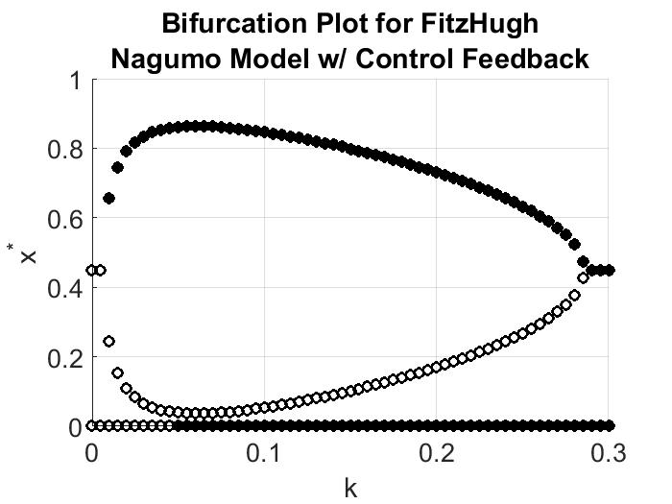

Figure 1. This is the bifurcation diagram for the modified system where there is control feedback for both u and v, and k is varied with 61 values. The filled in circles represent the stable fixed points that exist, while the unfilled circles represent the unstable fixed points.

According to the bifurcation plot, the fixed points vary from about 0 < x* <1 and their stability also vary through the variation of k. *The origin is a fixed point, and from 0 $≤$ k < 0.045, it is unstable, but from $0.045≤k≤0.3$, it is stable.* The other possible two fixed points, with respect to k, create a radical type function, and the larger fixed points are stable, while the smaller nontrivial fixed points are unstable. The exact values of the equilibrium points and their stability can be found in the stability.txt file the script that produces the bifurcation plot creates. However, the third portrait only shows one stable fixed point. The nullclines only cross once at the origin, and it is stable.

The origin is a fixed point for a values of k given, and two other fixed points occur are: $[u_{2,3}^{ *} , v_{2,3}^{ *}] =\frac{-(a+1)\sqrt{(a+1)^{2}-(k+a)}}{-2},\frac{ϵb}{ϵ+k}\frac{-(a+1)\sqrt{(a+1)^{2}-(k+a)}}{-2}$

The larger nontrivial fixed point is stable, while the nontrivial fixed point is unstable.

The bifurcation is related to k = 0.45. The plot at this value resembles a transcritical bifurcation because at the bifurcation point, the stability of the fixed at the origin changes. Another bifurcation occurs at about k = 0.285, and it is a saddle bifurcation because the number of fixed points change, and the set of unstable fixed points meet the stable fixed points at this bifurcation point. Maybe these equilibrium points are actually semi-stable?

In the bifurcation diagram, it shows that at the first bifurcation point found, the origin became stable, and it stayed stable for all values of k after 0.045.

I believe it is appropriate to only plot u* because the v*’s didn’t change value much. In Project 2, the phase portraits showed that the solutions mostly moved in u, and it’s the same case for this scenario. Also, the data file the script creates proves this. The u*’s changed from 0 to about 0.9, while the v*’s varied from about 0 to 0.03.

The nullclines for this system are different from the original system because of the extra parameters k, s_u, and s_v. The nullclines are shifted by these parameters when $(s_{u},s_{v})≠(0,0),$ but when it is (0,0), the nullclines still intercept at the origin, the shape only changes. For this case, the shape only changes. The u-nullcline and v-nullcline are in respective order:

$v=u(-u^{2}+(a+1)u-(a+k))+k*s_{u}$ $v=\frac{ϵ(bu-v)}{k}-s_{v}$

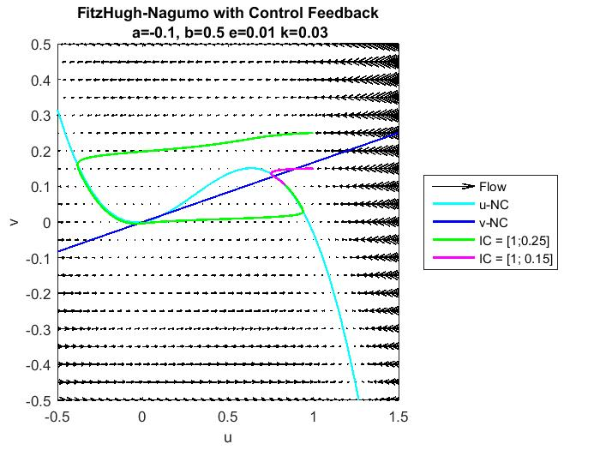

Figure 2. This is the phase portrait of modified system with a k value before the first bifurcation point. There are two unstable nontrivial fixed points and one trivial stable fixed point. The larger perturbation created a trajectory that went around the u-nullcline and just misses the unstable trivial fixed point. When zoomed in closer, the graph shows that the trajectory doesn’t go through the origin. It then follows the u-nullcline to the other fixed point. The purple trajectory crosses the stable fixed point. This k value is before the bifurcation point. The graph is consistent with data found earlier.

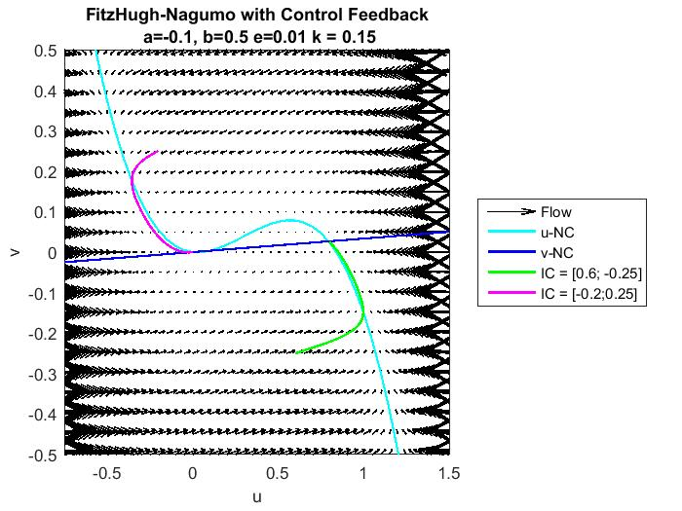

Figure 3. This is the phase portrait where the system has a k value between the two bifurcation points. There are 2 stable fixed points, and there is one unstable fixed point. Both trajectories end at a stable fixed point, but not the same one. This k-value is between the first and second bifurcation point, so the origin is a stable fixed point and the large nontrivial fixed point is stable as well. This graph is consistent with the data from earlier.

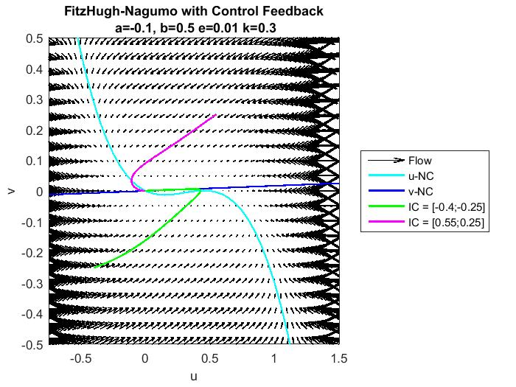

Figure 4. This is the phase portrait for when the system has a k value after the second bifurcation point. The bifurcation diagram says there should be two stable fixed points, but the nullclines only cross once, so this portrait only shows one. However, the purple trajectory, the larger perturbation, does end at the stable, trivial fixed point.

The control feedback affects the stability and quantity of fixed points fairly well with small values of k. The largest k used was 0.3, which is still a relatively small number. The feedback strategy is efficient in achieving desired behavior and desired equilibrium points.

The matrix below is the jacobian matrix of the modified system where u has control feedback.

$J@(0,0) = [0.1-k, -1; 0.005, -(0.01)]$

The matrix below is the jacobian matrix of the modified system where v has control feedback.

$J@(0,0) = [0.1, -1; 0.005, -(k+0.01)]$

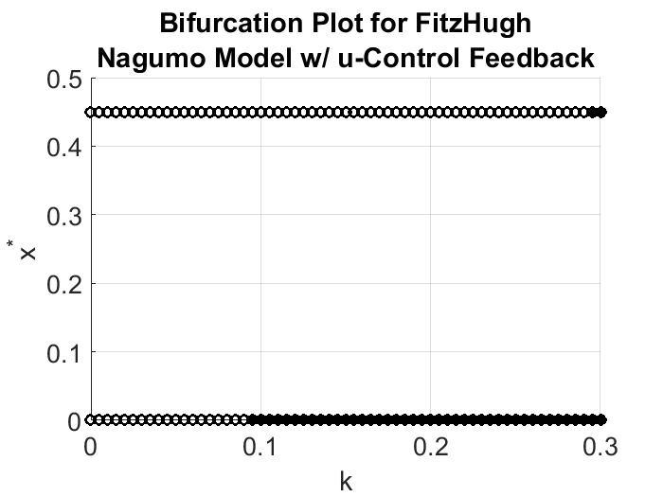

Figure 5. This bifurcation shows only 2 possible fixed points with 2 bifurcation points. The first one occurs at about k = 0.085, and it changes the stability of the trivial fixed point to stable. The second bifurcation point is at about 0.285, and it changes the nontrivial fixed point to stable.

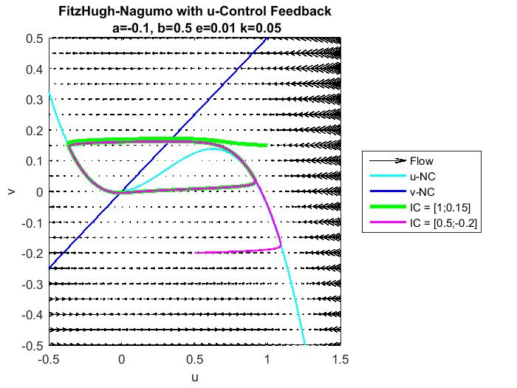

This phase portrait portrays the system with a k value

Figure 6. This is the phase portrait for the system with a k value before the first bifurcation. The purple trajectory, the smaller perturbation, appears to have a limit cycle. It starts of as a stable spiral, then loops into a oval like path. The green trajectory exhibits a limit cycle as well, which is easier to see when the line width is adjusted. It misses both fixed points, which agrees with data found earlier because both should be unstable.

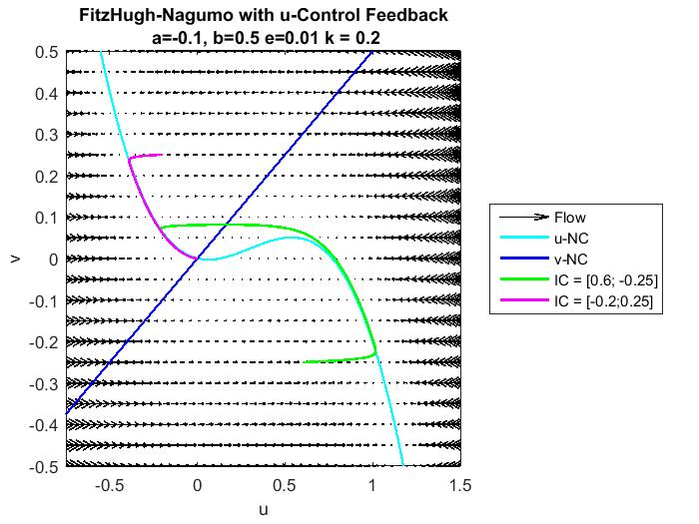

Figure 7. This phase portrait portrays the system with a k value between the two critical k values, k = 0.2. There is only one stable fixed point and both trajectories go toward it, and it is the origin. The nullclines only cross once, so the portrait only portrays one fixed point. However, the bifurcation plot shows two fixed points, where the nontrivial is unstable and the trivial is stable. It is consistent with the data for the trivial equilibrium point.

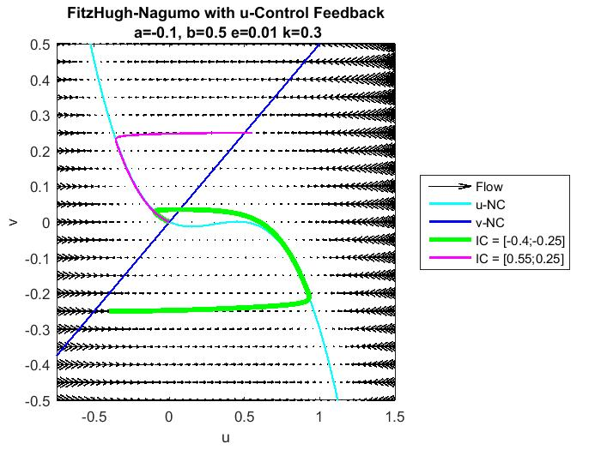

Figure 8. This phase portrait portrays the system with a k value after the second bifurcation point. There’s only one intersection between the nullclines, so the portrait only displays one fixed point. It is stable and at the origin, and both trajectories end at it. However, the bifurcation diagram showed two, so the data is not completely consistent.

For the system, the control feedback on the u-ODE allows the system to have 2 fixed points. They appear to the origin and at u* = 0.45. The stability of the trivial fixed point changes at about k = 0.085, while the stability of the nontrivial equilibrium point changes at the second critical k-value, about k = 0.285. After that and until k =0.3, both fixed points, according to the diagram, both fixed points are stable. However, the phase portraits only portrayed one fixed point for all cases.

Two bifurcations occur at values k = 0.085 and k = 0.285. The number of fixed points do not change; only the stability changes, therefore both are transcritical, but they are not ideal.

Increasing k from 0 eventually causes the origin to be stable, and only according to the bifurcation diagram, another nontrivial and positive fixed point is stable after the second bifurcation.

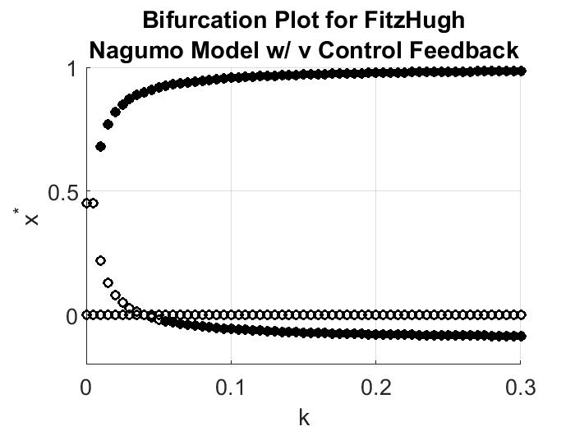

Figure 9. This is the bifurcation plot for when the system is only modified using control feedback on the v-ODE. The original system starts with two unstable fixed points, and as k is increase, the number of fixed points increase to 3. That occurs at about k = 0.015. It starts out as two unstable fixed points and one stable, then at about k = 0.06, there are two stable fixed points and one unstable. The values of the fixed point vary between about 0 and 1. They depend on k, so they change as k changes. These are the expressions of them in terms of the parameters and k:

$[u_{2,3}^{ *} , v_{2,3}^{ *}] =\frac{-(a+1)\sqrt{(a+1)^{2}-(a)}}{-2},\frac{ϵb}{ϵ+k}\frac{-(a+1)\sqrt{(a+1)^{2}-(a)}}{-2}$

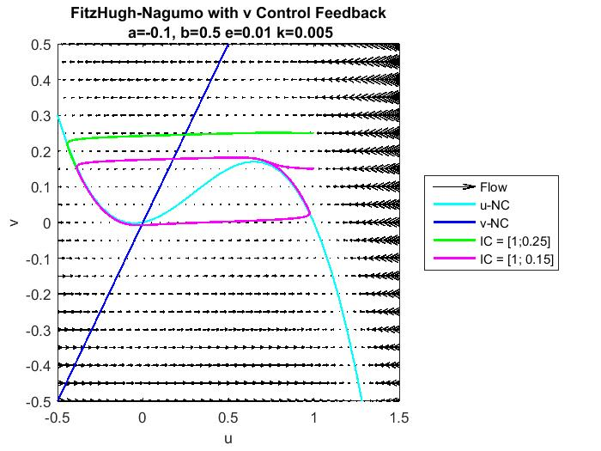

Figure 10. This is the phase plot for system with a k value before the first bifurcation k-critical value. Both trajectories start as stable spirals, then end in a limit cycle because it only has one possible equilibrium point, but it’s unstable, so they become stuck in the limit cycle. The nullclines only cross once, so only one fixed point is present, but according to the bifurcation plot, there should be two unstable fixed points.

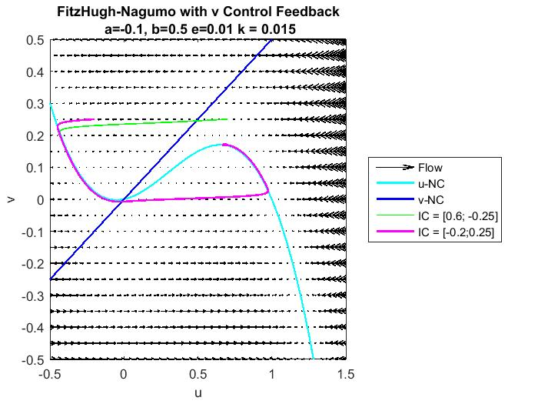

Figure 11. This is the phase portrait for the modified system with a k value between the two bifurcation points found from Figure 9. However, it stated that there should be two unstable fixed points and a stable fixed point, but there is only one unstable fixed point shown on this diagram. The purple trajectory, the one with a positive v-perturbation value, moves along the u-nullcline at first, but then glides outside of it and misses the origin because (0,0) is unstable still. Both trajectories end in very small limit cycles. On this diagram, one can notice a small bump at the top on the nullcline, and if zoomed in, one can see the cycles. Since only an unstable fixed point occurs in this diagram, the trajectories don’t have an equilibrium point to end at.

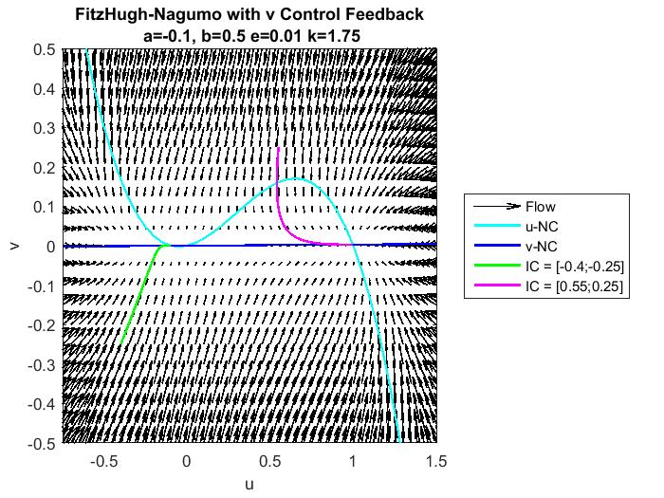

Figure 12. This the phase portrait of the modified system with a k value after the second bifurcation. There are two stable fixed points, where both are nontrivial. The negative fixed point appears to be 0, but that is only because it is relatively small. Although the bifurcation did show fixed points for k values after the second bifurcation point, this diagram doesn’t show the unstable fixed point Figure 9 showed.

The number of fixed points changed from 2 to 3 with only very small values of k, but as k grew, the stability of the negative fixed point changed to stable. The origin remains unstable. The other two fixed points depend on k:

$[u_{2,3}^{ *} , v_{2,3}^{ *}] =\frac{-(a+1)\sqrt{(a+1)^{2}-a}}{-2},\frac{ϵb}{ϵ+k}\frac{-(a+1)\sqrt{(a+1)^{2}-a}}{-2}$.

The bifurcation plot suggests there are two bifurcations with two critical values. One critical k is 0.015, and that is when the number of fixed points changed. The second occurs at about k = 0.06, and smaller fixed point becomes negative and stable. However, the phase portraits only recognize the origin until the second bifurcation point. The phase portraits suggest that there is one trivial unstable fixed point until about k = 0.06, and then there are two possible stable fixed points. The first bifurcation Figure 1 suggests isn’t valid, but the second one resembles a pitchfork supercritical bifurcation because if both the behavior in the portraits and the diagram are taken into account, they would create a bifurcation diagram where the system starts with just an unstable fixed point, then it changes into two stable fixed points.

Giving the v-ODE control feedback does not ever allow the origin to be a stable fixed point.

The most effective strategy appeared to be when control feedback were applied to both state variables because the origin was restored in stability, meaning, starting a certain k value, it was stable until the highest k value observed. It also agreed the most compared to the other two strategies, but it still was flawed in the third phase portrait. The second best is control feedback only onto v because it always had at least one stable fixed point (0<k $≤$ 3), where when it was only applied u, there was a set of k values that always had only unstable fixed points. The phase portraits did not agree with everything in the bifurcation diagram, but it had favorable results. The benefit of only applying control feedback to u was that it did have a stable origin starting at a particular k value.

**Model 2**

$\frac{du}{dt}=\frac{B}{2Δx}(T_{e}-T_{w})-C(u-u^{*})$; $\frac{dT_{w}}{dt}=\frac{u}{2Δx}(\underline{T}-T_{e})-r(T-{T_{w}}^{*})$; $\frac{dT_{e}}{dt}=\frac{-u}{2Δx}(\underline{T}-T_{w})-r(T^{*}-T_{e})$;

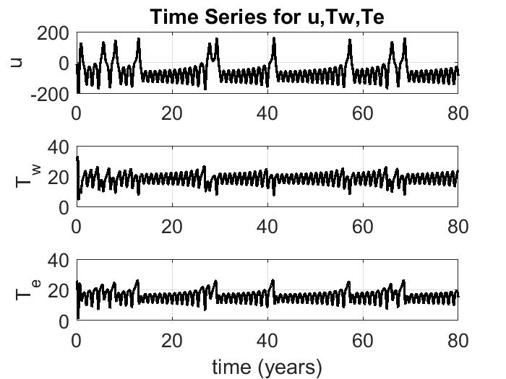

Figure 13. These are the time series graphs for each state variable of the original system. Chaos occurs because the oscillations are not at a consistent enough pattern. Random peaks appear on each graph.

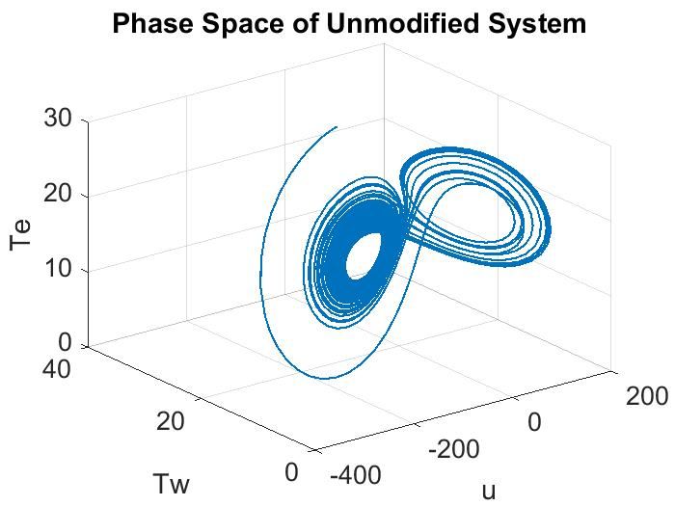

Figure 14. This diagram represents the phase space for the original ENSO model. It follow the Lorenz model, and it exhibits chaotic behavior in a similar way. They spiral at an increasing rate into each other from two different angles.

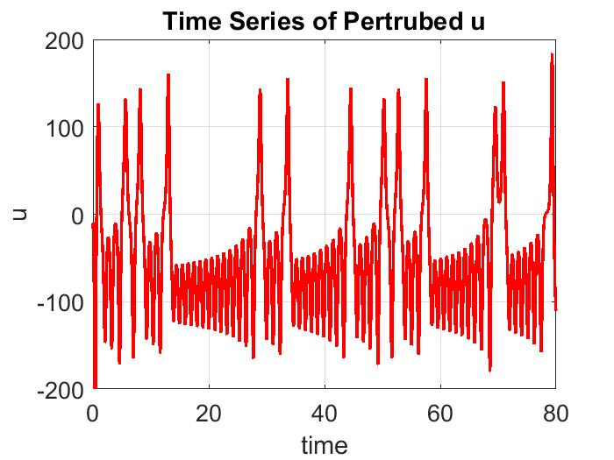

Figure 15. This is the time series graph for the perturbed u state variable. The perturbation caused a couple more spikes, but overall, it looks similar to the time series graph above. It portrays the chaotic behavior better because the peaks look much steeper, and they are supposed to.

The jacobian for this model is:

J = [ -C $\frac{-B}{2Δx}$ $\frac{B}{2Δx}$;

$\frac{(\underline{T}-T_{e})}{2Δx}$-r $\frac{-u}{2Δx}$;

$\frac{(T_{w}-\underline{T})}{2Δx}$ $\frac{u}{2Δx}$-r ]

Graphically, one can see that there is an unstable fixed point at about (0,18,15).

**Conclusion**

The world is too imperfect to depend on linear and general models to understand and predict it. Systems such as the weather need more complex models because often we have chaos, “imaginary” fixed points, unstable fixed points, and other undesired behavior. Control feedback can push and steer the system into particular points that will cause more useful and desirable behavior. They can especially be useful in 2D and 3D systems.

Collaborators:

Ali Borden: Shared ideas on discussions and analysis and helped one another’s codes

Allen Stanford: Helped with document coding

Mathworks: Helped with graphing and other coding issues

Calculator: quick arthimetic

Other resources: Project 2 analysis and phase portrait